Parallel Programming

CS575

Chao Zhang

Project #3

1. Source listing

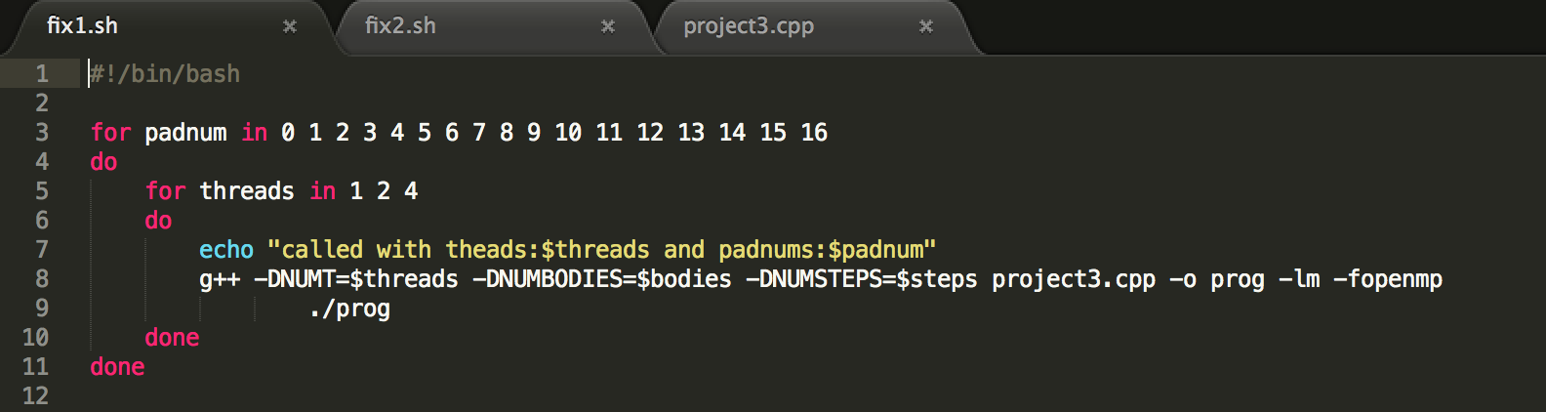

This is the fix1.sh file, it is used to run the program file which is the project3.cpp. The threads are 1, 2, 4. And I give the number of padding from 0 to 16.

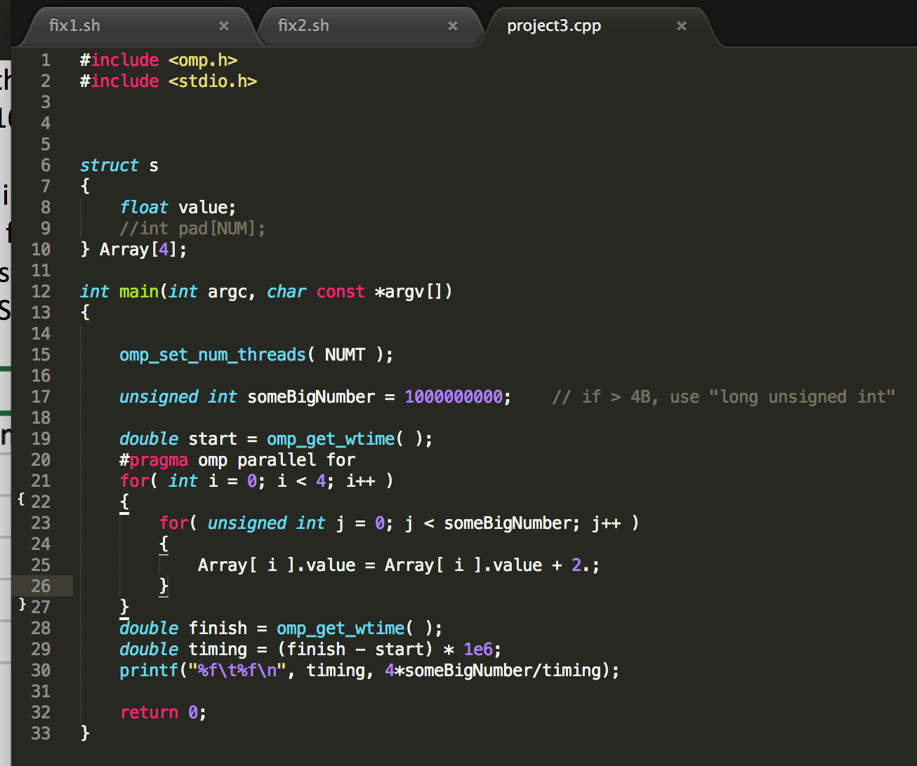

This code used for the fix. It will get the padnum the the NUMT from the .sh file. The out put will be the running time and the performance.

1. Result and analysis

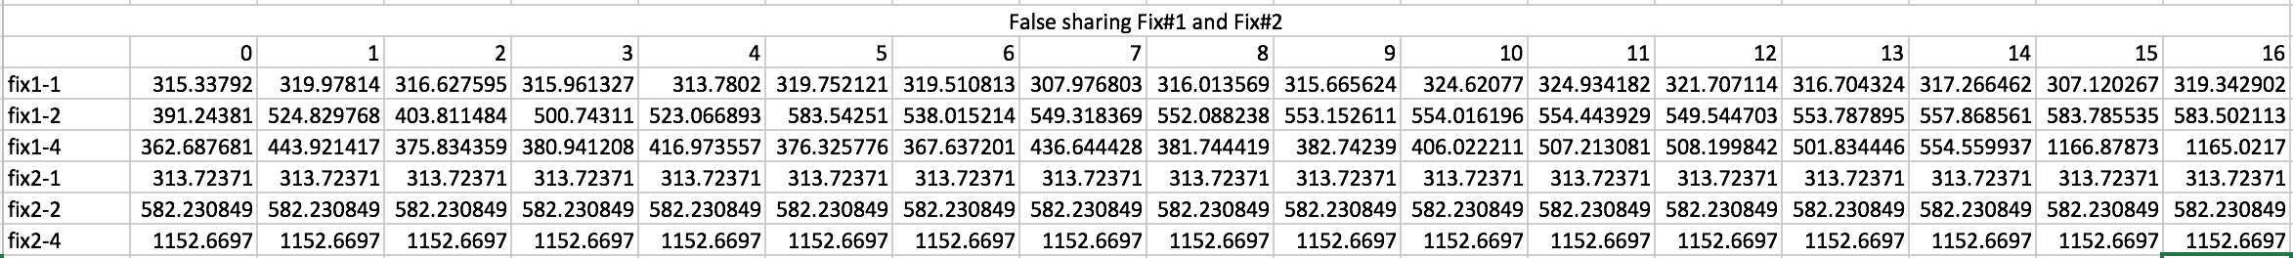

False sharing Fix #1 and Fix #2 Table

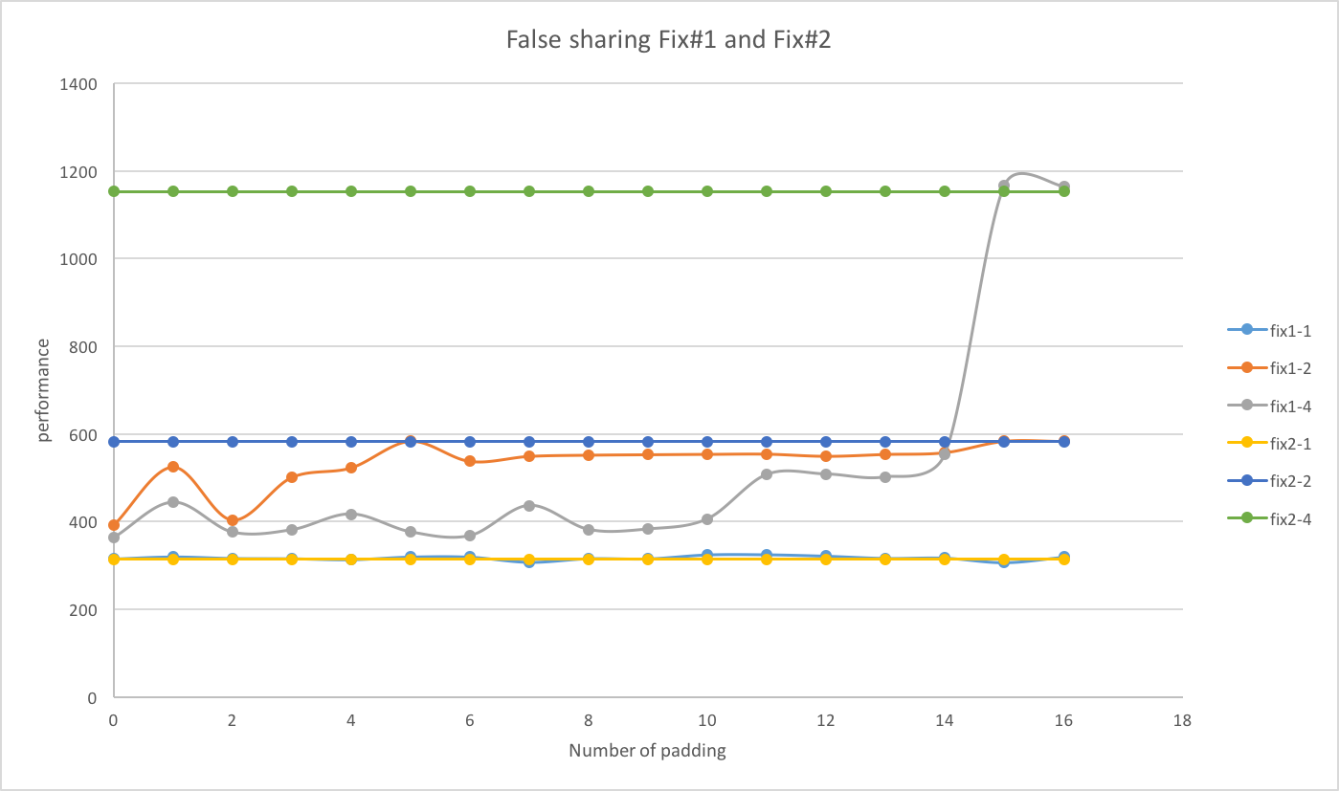

False sharing Fix #1 and Fix #2 Graphs

For the Fix #1, the 1 thread is almost a straight line. The two threads line increased at 5 and 7, for the 5, there is one data assigned to two cache lines, so both threads can read those lines at same time. For the 7, the reason may be the the cache lines have the same numbers of data. For the threads 4, the line also increased at 11 and 15. For the 11, it should have the same reason like the 5 with threads 2. And the 15, I think the reason is all the data fit in one cache line.

For the Fix #2, the pad number will not influence the performance of each Fix. For all fix #2, each stack has its own stack to take care of the local variables. That why it not changes the performance.